

Team: Ali Wael Ali Soliman
Ali Mohamed Ahmed
Ahmed Sayed El-Arabi
Nermin Awsy Khalil
Miral Alaa Hamed
Mariam Mohsen
Esraa Mohamed
Course: Network Security Technology
Lecturer: Dr. Zakaria Hassan

Design and implement network security to route multiple VLANs per company by using: Configure overall two VLANs with secure Cloud server
Table of Contents
1. Introduction: The problem & Vision 2
2. VLANs & Network Security 4
3. Routing Service 8
4. Cloud System 11
5. The Security Officer 13
6. Advanced Defense & Encryption 16
7. Quality Assurance 20
8. Project & Command Document 23

1. Planning Introduction
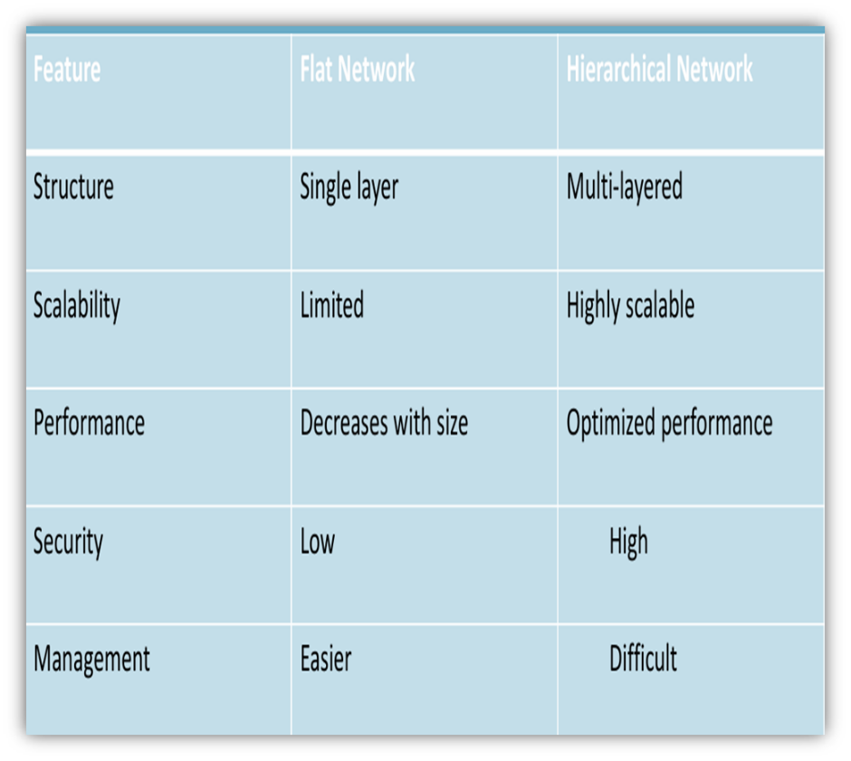
Traditional networks are no longer sufficient to meet the growing demands of modern organizations. They often suffer from poor scalability, limited control, and increased security risks. The key idea is to move from simple flat networks to more organized hierarchical networks.

- Cybersecurity Concept:
Cybersecurity refers to the technologies used to protect networks, systems, and data from unauthorized access, attacks, or damage. both organizations and individuals need to ensure data privacy, integrity, and availability

- Types Of Cybersecurity:
- Network Security.
- Application Security.
- Information Security (Data Security).
- Endpoint Security.
- Operational Security (OPSEC).
- Identity And Access Management (IAM).
- Cloud Security.
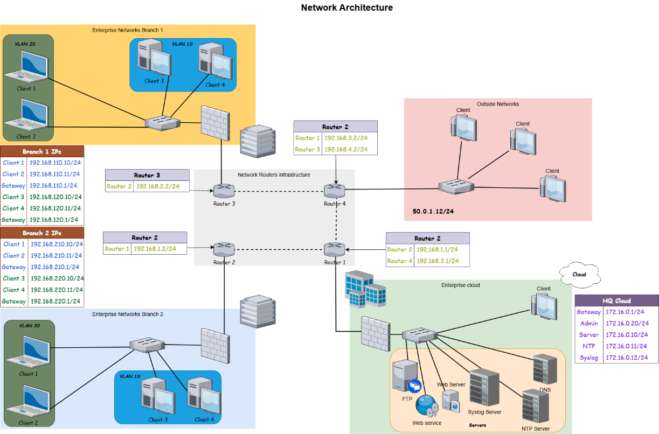

2. VLANs & Network Security
A VLAN (Virtual Local Area Network) is a logical grouping of network devices regardless of their physical location. VLANs are created by configuring switches to segment traffic as if the devices were on separate physical networks, without requiring additional hardware.
1.1 Core Concepts
Logical Separation | Devices in different VLANs cannot communicate directly — they require a Layer 3 router or switch to route traffic between segments. This boundary is enforced at the switch level.
Same Physical Switch | Multiple VLANs can coexist on a single physical switch with no additional hardware. The switch maintains separate forwarding tables and broadcast domains for each VLAN.
Trunk Links | A trunk port carries traffic for multiple VLANs simultaneously between switches using 802.1Q tagging. Each Ethernet frame is tagged with its VLAN identifier so the receiving switch knows which VLAN it belongs to.
2. VLANs and Network Security
VLANs are not merely a network design feature — they form a foundational layer of internal network security. By segmenting traffic logically, VLANs limit the impact of both external intrusions and insider threats.

2.1 Security Benefits
Traffic Isolation
Devices in one VLAN are invisible to devices in other VLANs. An attacker who compromises one segment cannot freely reach or enumerate hosts in other segments without passing through a controlled routing boundary.
Broadcast Containment
Broadcasts are confined within their VLAN. This prevents techniques such as ARP spoofing and broadcast storms from propagating across the entire network, significantly reducing the attack surface.
Departmental Separation
Organizational units such as Finance, Human Resources, and IT can each be assigned a dedicated VLAN. This ensures that employees cannot passively sniff or intercept traffic from other departments, even on shared physical infrastructure.
ACL Enforcement
Inter-VLAN traffic is directed through a firewall or Layer 3 router where Access Control Lists (ACLs) define exactly which communications are permitted. This creates a controlled inspection point for all cross-segment traffic.
Internal Threat Defense
The majority of security incidents originate inside the network perimeter. VLANs function as internal firewalls, requiring lateral movement to pass through monitored inspection points rather than traversing freely across segments.
Guest Network Isolation
Guest users and visitors can be assigned to a dedicated guest VLAN that provides internet access while maintaining zero visibility into internal corporate resources and infrastructure.

3. VLAN Hopping Attacks
VLAN hopping is a category of network attack in which an adversary gains access to traffic on VLANs beyond those they are legitimately authorized to access. Two primary techniques exist: Switch Spoofing and Double Tagging.
3.1 Switch Spoofing
How it Works
The attacker configures their network interface card (NIC) to negotiate a trunk link with an adjacent switch using DTP (Dynamic Trunking Protocol). Once the trunk is established, the attacker's device receives traffic from all VLANs carried on that trunk, rather than just their assigned access VLAN.
Why it Works
Switches with DTP enabled will automatically negotiate trunk links with connecting devices. This default behavior, intended to simplify legitimate switch-to-switch connectivity, can be exploited by an attacker to elevate their network access without any additional authentication.
3.2 Double Tagging
How it Works
The attacker crafts an Ethernet frame containing two nested 802.1Q VLAN tags. The outer tag matches the native VLAN of the first switch and is stripped during forwarding. The inner tag then causes the frame to be delivered to a different, target VLAN on the next switch in the path.
Attack Limitation
Double tagging is a unidirectional attack. The attacker can inject frames into the target VLAN but cannot receive replies directly, as return traffic will be addressed to the victim VLAN rather than the attacker's VLAN. Despite this limitation, it can be used effectively for denial-of-service or one-way data injection.
4. Secure VLAN Configuration
Proper VLAN security requires deliberate configuration hardening. The following measures address the most common attack vectors and misconfigurations observed in enterprise environments.
01 | Disable DTP on Access Ports  Execute switchport nonegotiate and set all end-device ports to static access mode. This prevents any attached device from negotiating a trunk link and eliminates the switch spoofing attack surface entirely.
02 | Change the Native VLAN  Never use the default VLAN 1 as the native VLAN on trunk ports. Assign a dedicated, otherwise unused VLAN ID (e.g., VLAN 999) to serve as the native VLAN. This neutralises double-tagging attacks that rely on the default native VLAN.
03 | Disable Unused Ports  Administratively shut down all switch ports that do not have an active, authorised device connected. Assign disabled ports to an isolated, unused VLAN to prevent unauthorised device connections or physical access attacks.
04 | Explicit Trunk Configuration  Manually configure all trunk ports rather than relying on automatic negotiation. Specify exactly which VLANs are permitted on each trunk link using the allowed VLAN list, removing all VLANs that have no legitimate reason to traverse that link.
05 | Enable Port Security  Configure port security to limit the number of MAC addresses permitted per port. Lock critical ports to specific authorised MAC addresses to prevent MAC flooding attacks that could overflow the CAM table and cause the switch to broadcast all traffic.
06 | Combine with ACLs and Firewall  VLANs alone do not constitute a complete security solution. Apply ACLs at all Layer 3 inter-VLAN boundaries and deploy a firewall to inspect, log, and control traffic flowing between segments. Segmentation and filtering must be applied in combination.

3. Routing & Services
1. Fundamentals of Network Routing
Routing is the core mechanism of the Network Layer (Layer 3) that enables data to travel beyond its local segment. It is the process of selecting the optimal path for forwarding packets from a source in one network to a destination in another, guided by a local Routing Table.
Routing Methodologies
- Static Routing:
  - Description: Manually configured by the network administrator.
  - Advantages: Predictable, low overhead (no CPU/RAM used for updates), and inherently secure as no routing protocols are exchanged.
  - Disadvantages: Not scalable; if a link fails, the path does not update automatically.
- Dynamic Routing:
  - Description: Routers use protocols (like OSPF or EIGRP) to discover neighbors and exchange topology information.
  - Advantages: Automatic path recalculation and highly scalable for large infrastructures.
  - Disadvantages: Requires more system resources and is susceptible to protocol-based attacks if not authenticated.

2. Inter-VLAN Routing: Breaking Broadcast Domains
By default, devices in different VLANs are isolated at Layer 2 to reduce broadcast traffic and enhance security. To allow these devices to communicate, a Layer 3 device must be introduced to perform "Inter-VLAN Routing."
Primary Implementation Techniques
- Router-on-a-Stick (RoaS): * Uses a single physical interface on a router divided into multiple logical sub-interfaces.
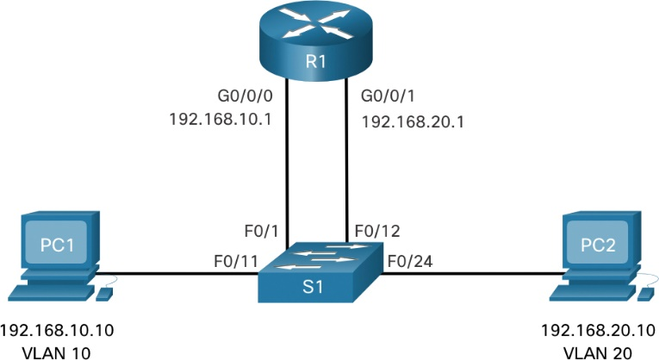
  - Each sub-interface acts as the default gateway for a specific VLAN using 802.1Q trunking.
- Switched Virtual Interfaces (SVIs): * Configured on Layer 3 (Multilayer) Switches.
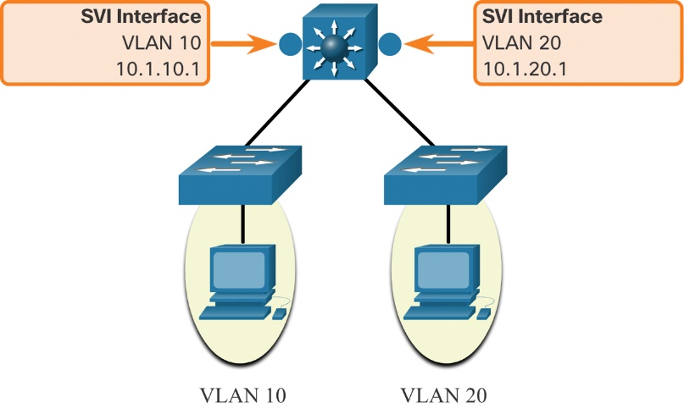
  - The switch performs routing at hardware speeds using virtual interfaces assigned to each VLAN, offering much higher performance than RoaS.
3. Security Implications in Routing
While routing enables connectivity, it also expands the "attack surface" of the network. If the routing logic is compromised, the entire security posture collapses.
Identified Risks
- Route Injection: Attackers introducing fraudulent routes to redirect sensitive traffic.
- Traffic Interception: Unauthorized nodes capturing data as it transitions between different network segments.
- VLAN Hopping & Isolation Loss: If Inter-VLAN routing is not strictly controlled, an attacker in a low-security VLAN can reach high-security servers (lateral movement).
4. Advanced Mitigation & Traffic Control
To maintain a secure "Defense-in-Depth" environment, routing must be coupled with the following security controls:
- Route Authentication: (e.g., OSPF MD5) Ensuring that only trusted routers can participate in the routing process.
- Access Control Lists (ACLs): Implementing "Gatekeepers" at the routing interface to permit or deny traffic based on source, destination, and port.
- Internal Firewalls: Deploying stateful inspection firewalls (like Cisco ASA) at the boundaries between critical VLANs to deep-scan traffic for malicious patterns.

4. Cloud System
Cloud System Overview
The Cloud System is an essential part of modern network design, serving as the central hub that provides services to all users on the network. Instead of using separate local servers in each department, all services are consolidated into a single centralized cloud environment, making management easier and improving performance and availability.
Cloud Providers
Cloud services are provided by well-known companies such as Amazon Web Services, Microsoft Azure, and Google Cloud Platform. These providers offer ready-to-use infrastructure and tools that help organizations run their systems efficiently and securely.
Cloud Services
The cloud provides several important services. Web services (HTTP/HTTPS) allow users to access applications through browsers. DNS is used to translate domain names into IP addresses, while DHCP automatically assigns IP addresses to devices. There are also authentication services that verify user identity before allowing access, as well as storage and database services for saving and managing data. In addition, file transfer services (FTP/SFTP) and remote access tools (SSH/VPN) are used to manage systems securely.
Security Services
Security is a key feature in cloud systems. Cloud providers include built-in security services such as encryption to protect data, access control (IAM) to manage user permissions, and firewalls to filter and monitor network traffic. These features help protect the system from unauthorized access and cyber threats.
Cloud Service Models
Cloud computing is divided into three main service models. SaaS (Software as a Service) provides ready-to-use applications for end users, such as Gmail and Office 365. PaaS (Platform as a Service) offers a platform for developers to build and run applications, such as Heroku and Google App Engine. IaaS (Infrastructure as a Service) provides full control over virtual machines and networking resources, such as Amazon EC2 and Microsoft Azure.
Control & Integration
In general, the level of control increases from SaaS to IaaS. These cloud services are integrated with the network, where devices from different VLANs use routing to access the cloud. Therefore, the cloud becomes the central point that delivers services to the entire network.
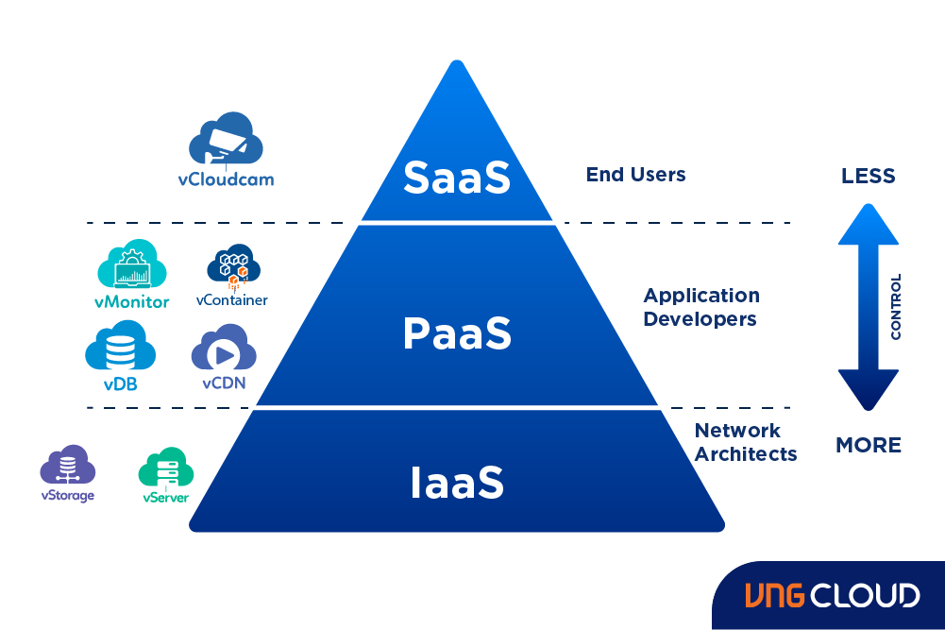
5. The Security Officer
1. Introduction to Defense-in-Depth (DiD)
The Defense-in-Depth (DiD) strategy is a layered approach to cybersecurity that implements multiple security controls throughout an information technology (IT) system. The core philosophy is that if one security layer fails, others are in place to stop the threat. This specific section focuses on the Security Officer's role in Endpoint & Device Protection, emphasizing the hardening of network infrastructure (Routers and Switches) against common vulnerabilities.

2. Common Network Threats & Vulnerabilities
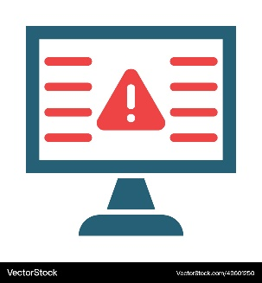
To effectively defend a network, we must first identify the primary attack vectors. The following threats are critical concerns for modern network environments:
- Unauthorized Physical Access: The risk of an intruder gaining physical proximity to hardware to tamper with or bypass security.
- MAC Address Spoofing: A technique where an attacker alters the factory-assigned MAC address of a device to masquerade as a legitimate node.
- Brute-Force Attacks: Automated attempts to guess administrative credentials (passwords) to gain control over network devices.
- Man-in-the-Middle (MITM) & Sniffing: Intercepting and potentially altering data as it travels between two legitimate endpoints.
- IP Spoofing: Creating IP packets with a false source IP address to impersonate another computer system.
- Lateral Movement & Blindness: Once inside, attackers move through the network to escalate privileges while staying undetected.
3. Mitigating Unauthorized Physical Access
The first line of defense is securing the physical ports on networking equipment to prevent illegal connections.
Solution: Port Security & Shutdown Policy
The most effective way to prevent an intruder from unplugging a legitimate device and connecting a malicious laptop is through strict port management:
- Closing Unused Ports: Any port not actively in use should be administratively shut down to prevent "plug-and-play" exploitation.
- Port Security Implementation: Restricting input to an interface by limiting the MAC addresses allowed.
  - Sticky MAC addresses: Dynamically learning and "sticking" the MAC address to the configuration.
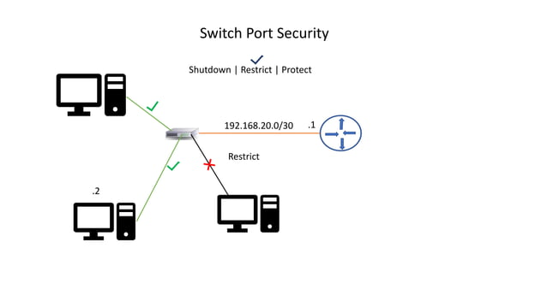
  - Violation Restrict: Dropping packets from unauthorized MACs while keeping the port operational (but logged).

4. Defending Against Management Attacks
Administrative access to routers and switches must be heavily guarded to prevent Brute-Force attacks and credential guessing via Console or VTY (Virtual Terminal) lines.
A. Secure Login System & Privilege Control
Establishing a secure identity management system ensures that only authorized personnel can access the configuration mode.
- Encrypted Enable Password: Using enable secret ensures the administrative password is encrypted.
- Banners: Legal warnings to deter unauthorized users.
- Local Databases: Creating specific usernames with defined privilege levels.
B. Secure Shell (SSH) Implementation
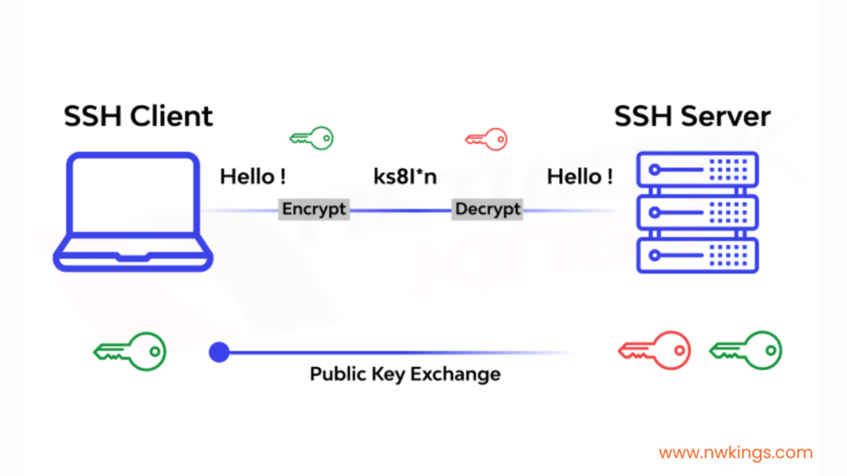
Telnet is inherently insecure as it sends data in plain text. SSH is the mandatory alternative for encrypted remote management.
C. Brute-Force Protection & Password Integrity
To further harden the system, we implement automated blocks for failed login attempts and enforce password complexity.
- Login Blocking: Automatically disabling login capabilities if multiple failed attempts occur within a specific window.
- Password Encryption & Length: Ensuring all passwords stored in the configuration are hashed and meet a minimum length requirement.
6. Advanced Defense & Encryption
1. Introduction
Building on the previous layers of security, this section addresses the protection of data in transit and the integrity of the routing infrastructure. Traffic & Perimeter Security focuses on preventing interception, mitigating unauthorized lateral movement within the network, and ensuring that all network events are accurately logged and synchronized for forensic purposes.
2. Routing Infrastructure Security
The core of network communication relies on routing protocols. If these protocols are compromised, the entire network traffic can be redirected.
- The Threat: Routing Protocol Poisoning & Fake Updates. An attacker may connect a rogue router to inject false routing information. This leads to Black-holing (traffic loss) or Man-in-the-Middle (MITM) attacks where traffic is redirected through the attacker's device.
- The Solution: OSPF MD5 Authentication. By enabling MD5 authentication, routers will only accept routing updates from neighbors that share the same secret key.
3. Preventing Sniffing & MITM Attacks (Site-to-Site VPN)
When data travels over untrusted links (like the Internet) between branches, it is vulnerable to eavesdropping and interception.
- The Threat: Packet Sniffing & Eavesdropping. Sensitive data packets are intercepted by unauthorized parties.
- The Solution: Site-to-Site IPsec VPN. This creates a secure, encrypted tunnel between network nodes (R1, R2, R3).
  - Encryption (AES): Ensures data confidentiality.
  - Authentication (SHA Hashing): Guarantees data integrity and verifies the sender.
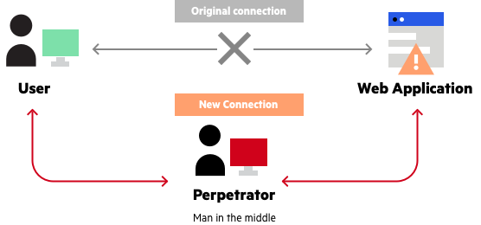
  - ISAKMP Policy: Defines the "handshake" parameters for the secure tunnel.
4. Restricting Lateral Movement (Traffic Filtering)
Internal security is just as important as perimeter security. Once an attacker (or a compromised user) is inside a network, they often try to move between VLANs to access restricted servers.
- The Threat: Internal Unauthorized Access. A user in a standard VLAN (e.g., VLAN 10) attempting to access sensitive services (like WEB or FTP) on a server they are not authorized to use.
- The Solution: Extended Access Control Lists (ACLs). Extended ACLs provide granular control by filtering traffic based on source/destination IP and specific port numbers (TCP/UDP).
  - The "Deny All" Rule: Standard practice dictates denying all traffic by default and only permitting what is necessary.

5. Countering Identity Theft & Forensic Blindness
Maintaining a clear and untamperable record of network events is crucial for incident response and legal forensics.
A. Anti-Spoofing (ACL 102)
- Threat: IP Spoofing. External attackers faking internal IP addresses to bypass security filters.
- Solution: Implementing ACLs at the perimeter that drop packets claiming to be from internal ranges if they arrive from the outside.
B. NTP Synchronization
- Threat: Unsynchronized Clocks. Inconsistent timestamps make it impossible to reconstruct the timeline of an attack across different devices.
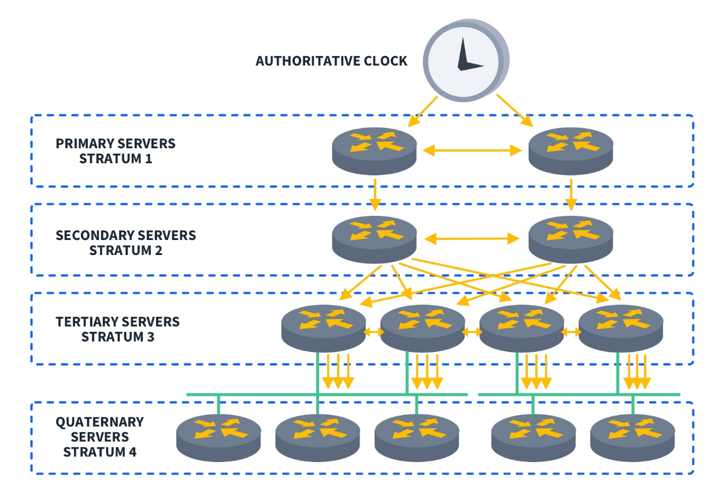
- Solution: Centralizing time management via an NTP Server.

C. Centralized Monitoring (Remote Syslog)
- Threat: Log Tampering. Attackers often delete local logs to hide their tracks.
- Solution: Sending all system logs to a dedicated Remote Syslog Server.
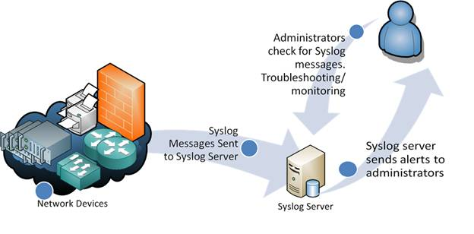
7. Quality Assurance
1. Quality Assurance in Network Systems
Quality Assurance (QA) is a critical process in network systems to ensure that the network operates reliably, securely, and as intended.
It involves testing, validation, and continuous monitoring to detect issues and confirm that both connectivity and security mechanisms are functioning properly.
In modern network design, QA focuses not only on performance but also on risk mitigation, ensuring that the system can resist attacks and handle real-world scenarios effectively.
1.1. Validation
verifying that the network is functioning correctly by testing:
- End-to-end connectivity between branches and HQ
- Inter-VLAN communication
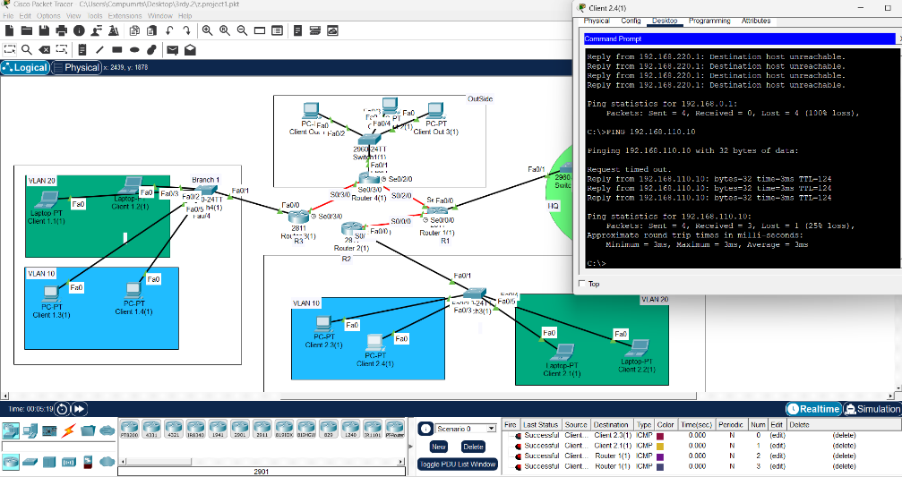
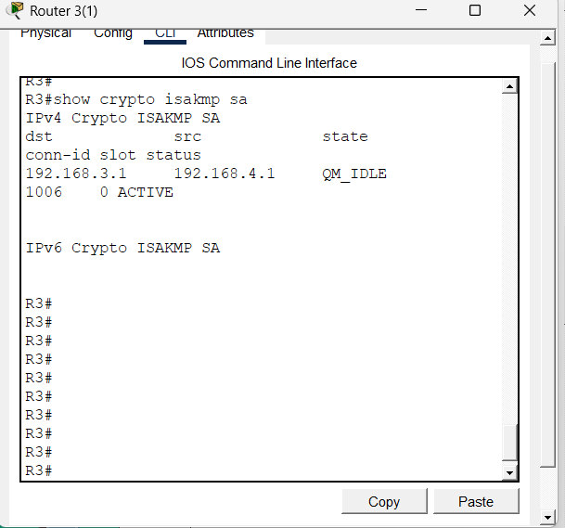
- VPN tunnel establishment
2.1. Risk Mitigation
validating that the implemented security mechanisms are functioning as expected:
- ACLs correctly allow and deny traffic
- SSH restricts unauthorized access attempts
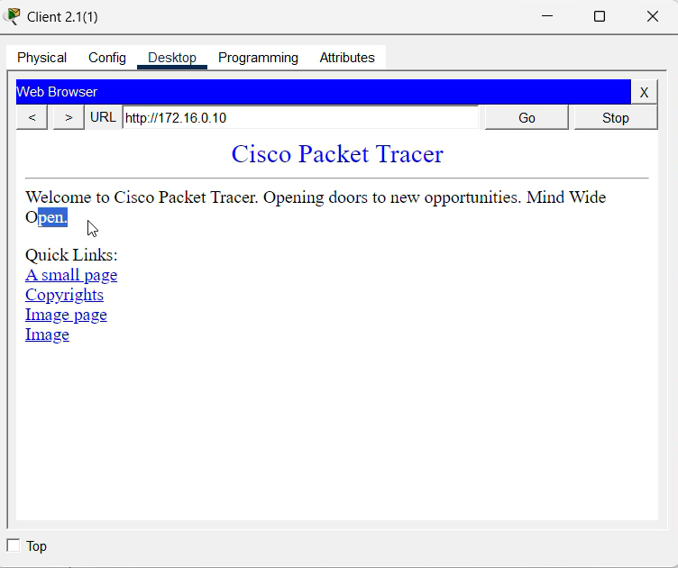
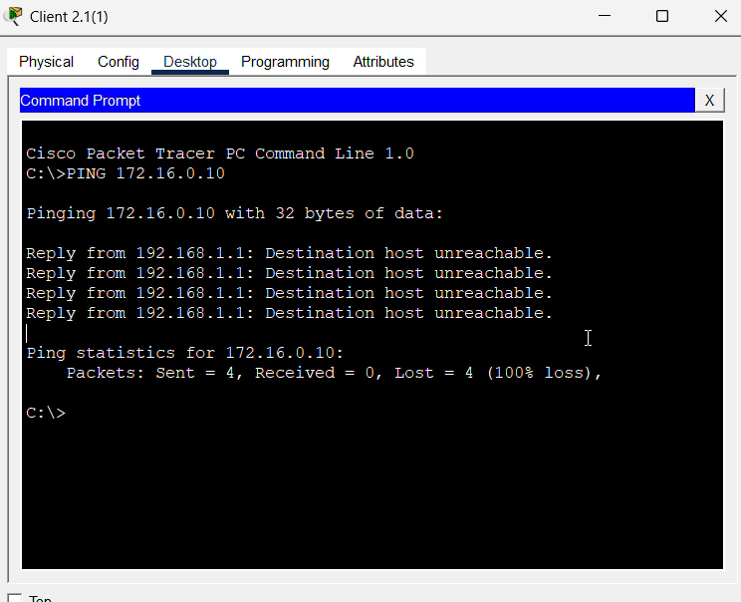

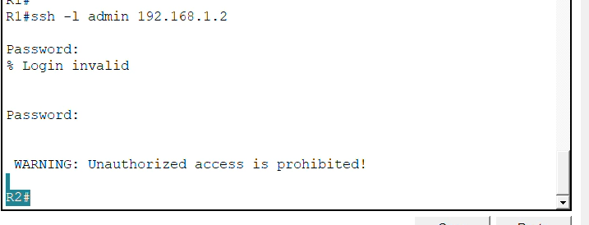

2. Attack Simulation (Brute Force)
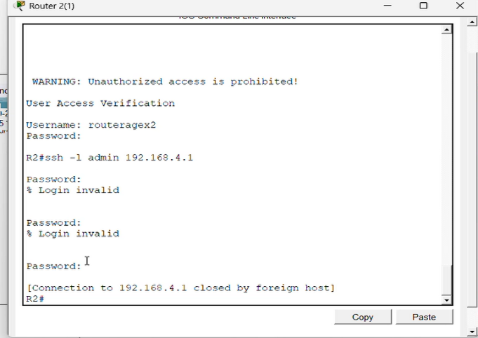
Simulating a brute-force attack on remote access to test security controls.
- Multiple login attempts were performed on SSH
- Unauthorized access was denied
- Login attempts were limited and blocked

3. Designing a Secure Network System
3.1 System Design Mindset:
- Plan Before You Build
Design with structure and scalability, not random connections.
- Control Access
Only authorized users and devices should be allowed.
- Secure by Default
Disable unused services and use secure protocols only
3.2 System Security Principles:
- Assume Threats
Always design as if attacks will happen.
- Monitor Continuously
Track logs and network activity for visibility.
- Validate Regularly
Test connectivity and security — never assume

8. Project & Command Document
This section provides a detailed breakdown of the Command Line Interface (CLI) steps executed to configure the network infrastructure.
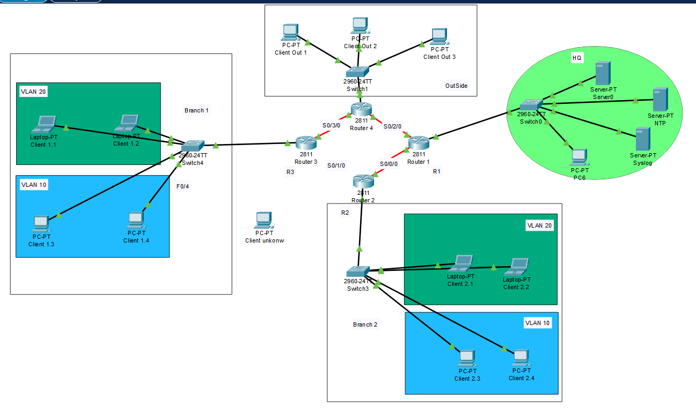
1. Inter-VLAN Routing (Router-on-a-Stick)
To enable communication between different VLANs, logical sub-interfaces were created on the router's physical interface.
- Step 1: Configure Sub-interface for VLAN 10
Router>enable
Router#configure terminal
Router(config)#interface fa0/0.10
Router(config-subif)#encapsulation dot1Q 10
Router(config-subif)#ip address 192.168.110.1 255.255.255.0
Router(config-subif)#exit
- Step 2: Configure Sub-interface for VLAN 20
Router(config)#interface fa0/0.20
Router(config-subif)#encapsulation dot1Q 20
Router(config-subif)#ip address 192.168.120.1 255.255.255.0
Router(config-subif)#no shutdown
2. Management Plane Security (SSH & Hardening)
Securing administrative access to the devices via encrypted SSH and password policies.
- Step 1: Basic Hardening and Local Database
Router(config)#hostname R1
R1(config)#enable secret agex112026
R1(config)#username admin privilege 15 secret agex332026login1
- Step 2: SSH Service Configuration
R1(config)#ip domain-name AgeX.com
R1(config)#crypto key generate rsa
# (Enter 1024 when prompted for bits) 1024
R1(config)#ip ssh version 2
- Step 3: Secure VTY Lines
R1(config)#line vty 0 4
R1(config-line)#login local
R1(config-line)#transport input ssh
R1(config-line)#logging synchronous
R1(config-line)#exit

3. Dynamic Routing Security (OSPF Authentication)
Securing the routing protocol exchange using MD5 hashing to prevent route injection.
- Step 1: Basic OSPF Process
R1(config)#router ospf 1
R1(config-router)#network 192.168.1.0 0.0.0.3 area 0
R1(config-router)#exit

- Step 2: Enable MD5 Authentication on Interface
R1(config)#interface Serial0/0/0
R1(config-if)#ip ospf message-digest-key 1 md5 agex2026pass
R1(config-if)#ip ospf authentication message-digest
4. Layer 2 Perimeter Defense (Port Security)
Implementing physical port security on access switches to restrict unauthorized device connection.
- Step 1: Interface Security Policy
Switch(config)#interface range fa0/2-24, g0/1-2
Switch(config-if-range)#switchport mode access
Switch(config-if-range)#switchport port-security
Switch(config-if-range)#switchport port-security maximum 1
Switch(config-if-range)#switchport port-security mac-address sticky
Switch(config-if-range)#switchport port-security violation restrict
5. Site-to-Site IPsec VPN (Data Encryption)
Creating an encrypted tunnel between R1 and R2 for secure data transit.
- Step 1: ISAKMP Policy (Phase 1)
R1(config)#crypto isakmp policy 10
R1(config-isakmp)#encryption aes
R1(config-isakmp)#hash sha
R1(config-isakmp)#authentication pre-share
R1(config-isakmp)#group 2
R1(config-isakmp)#exit
R1(config)#crypto isakmp key agex address 192.168.3.1

- Step 2: IPsec Transform Set & Map (Phase 2)
R1(config)#crypto ipsec transform-set R1->R2 esp-aes esp-sha-hmac
R1(config)#crypto map VPN_MAP 10 ipsec-isakmp
R1(config-crypto-map)#set peer 192.168.3.1
R1(config-crypto-map)#set transform-set R1->R2
R1(config-crypto-map)#match address 110
- Step 3: Apply VPN to Interface
R1(config)#interface Serial0/0/0
R1(config-if)#crypto map VPN_MAP

6. System Services & Verification
Setting up monitoring services and verifying the operational status.
- Step 1: NTP and Syslog Configuration
R1(config)#ntp server 172.16.0.11
R1(config)#logging host 172.16.0.12
R1(config)#service timestamps log datetime msec
- Step 2: Verification Commands (Privileged EXEC Mode)
R1#show ip route #Check Routing Table
R1#show ip interface brief #Check Interface Status
R1#show port-security #Verify Port Security
R1#show crypto isakmp sa #Check VPN Tunnel Status

